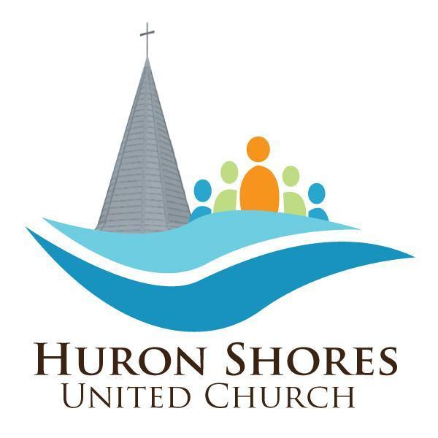
25 Main Street, P.O. Box 61, Grand Bend, Ontario N0M 1T0 * (519) 238-2402 huronshoresunitedchurch@gmail.com * www.huronshoresunitedchurch.com

December 22, 2021

WHY GO TO CHURCH?

During this questionable time in our history, having something to think about other than doom and gloom is not only helpful but healthful and hopeful. In the story below, it reminds us to keep positive in our thinking and hopeful in our spirit. Since we also have been married over 30 years, we appreciate the fellow’s answer, and the interpretation of the word ‘BIBLE’ at the bottom of the page.

• If you’re spiritually alive, you’re going to love this.
• If you’re spiritually dead, you won’t want to read it.
• If you’re spiritually curious, there is still hope.

A Church goer wrote a letter to the editor of a newspaper and complained that it made no sense to go to Church every Sunday.

He wrote: “I’ve gone for 30 years now and in that time, I have heard something like 3,000 sermons, but for the life of me, I can’t remember a single one of them. So, I think I’m wasting my time, the preachers and priests are wasting theirs by giving sermons at all”.

This started a real controversy in the “Letters to the Editor” column. Much to the delight of the Editor, it went on for weeks until someone wrote this clincher:

I’ve been married for 30 years now. In that time frame my wife has cooked some 32,000 meals. But, for the life of me, I cannot recall the entire menu for a single one of those meals.

But I do know this: They all nourished me and gave me the strength I needed to do my work. If my wife had not given me these meals, I would be physically dead today.

Likewise, if I had not gone to Church for nourishment, I would be spiritually dead today!”

Thank God for our physical and spiritual nourishment.

Wishing you all a new year full of HOPE, JOY, PEACE, AND LOVE.

Melodie and Steve Northey

B.I.B.L.E. simply means: Basic Instructions Before Leaving Earth!

"Our relationship with God and each other strengthens us, and helps make the world a better place.
We welcome and include everyone into congregational life."

